**Commands**

1. **Ipconfig/all:**

* gives the full configuration of the system.
* Refreshes all DHCP (Dynamic Host Configuration Protocol) leases and re-registers the DNS (Domain Name System – ‘the Phonebook of the Inernet’) names.

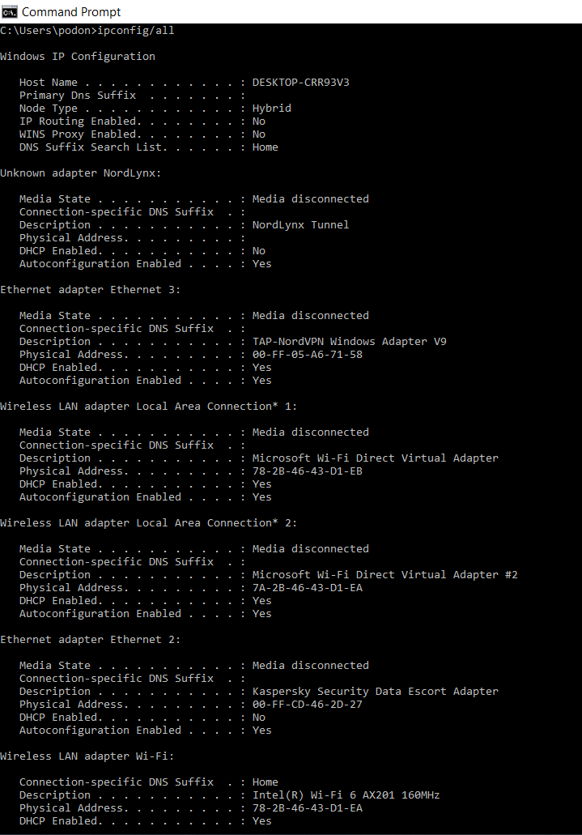

1. **ping**

Tests the ability of the source computer to reach a specified destination computer e.g. bbc.co.uk

Verifies if a computer can communicate over the network with another computer or network device.

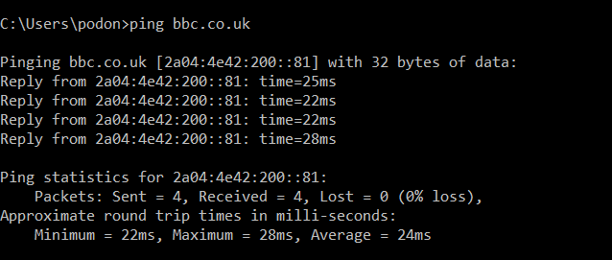

1. **Arp**

Allows you to display the Address Resolution Protocol to determine the MAC (Media Access Control) address for an IP address. It records the mapping in the ARP cache so that future ARP lookups go faster.

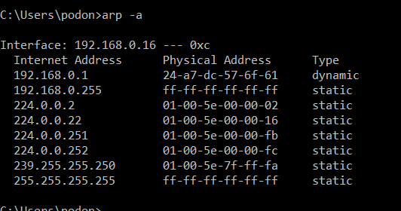

1. **Nslookup**

Stands for Name Server Lookup. Obtains information from the DNS server I.e. Domain Name, mail servers and IP address.

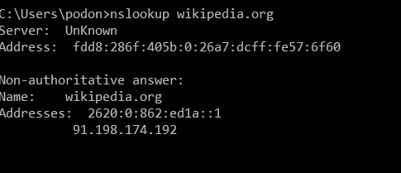

1. **Netstat**

Generates displays that show network status and protocol statistics of TCP (Transmission Control Protocol), routing tables, and a number of network protocol statistics.

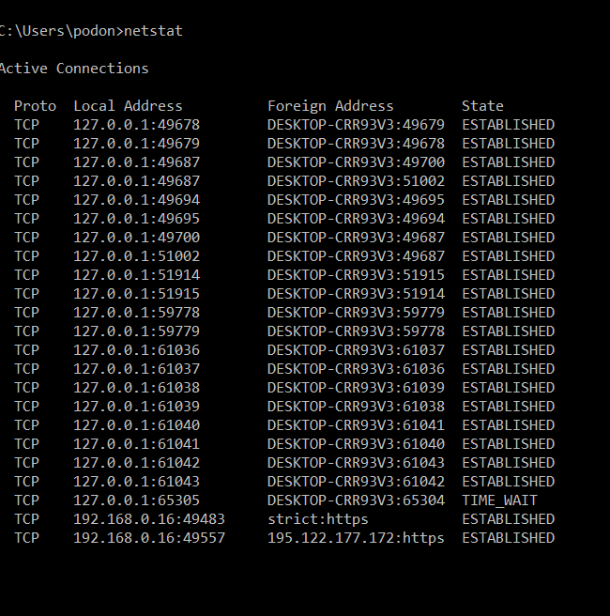

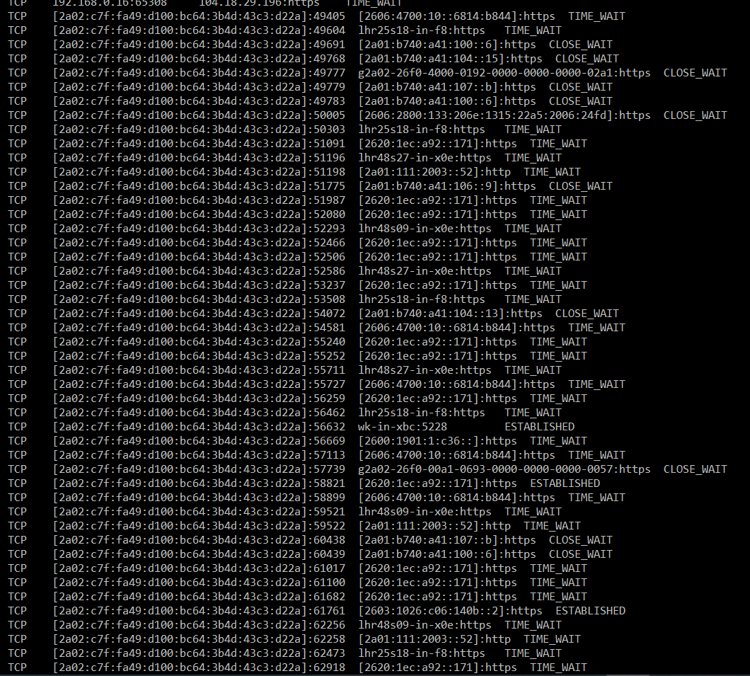

1. **Tracert**

Shows several details about the path a packet takes from the computer or device you’re on to the destination you specify in this instance skysport.com

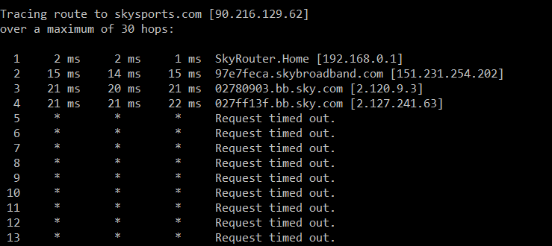

1. **Route**

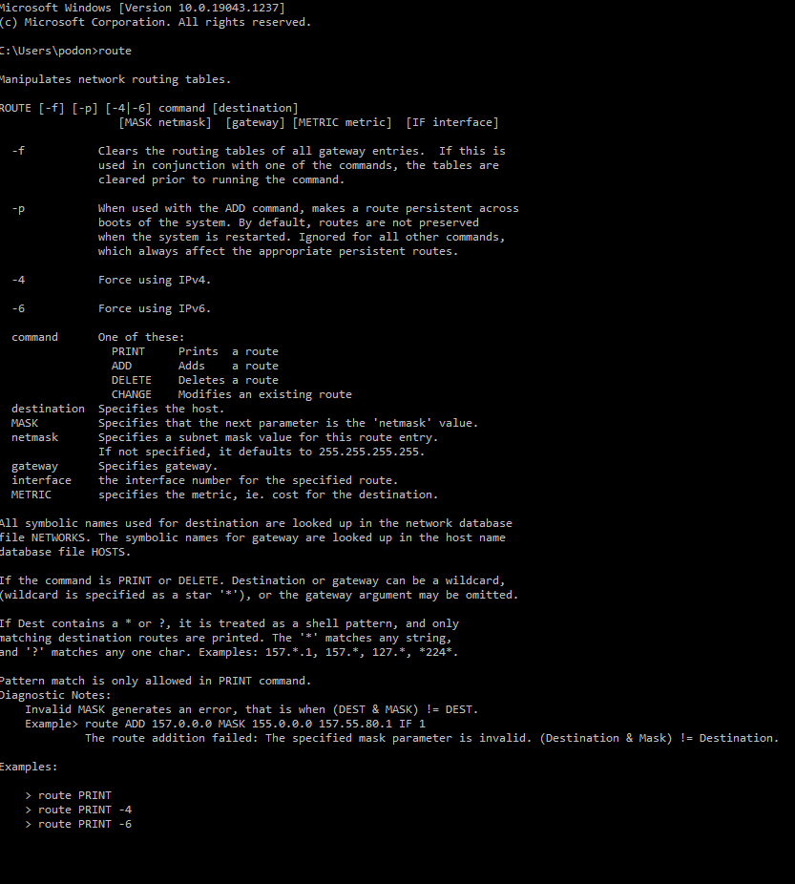

**‘Route PRINT’ :**  View the list of registered persistent routes

